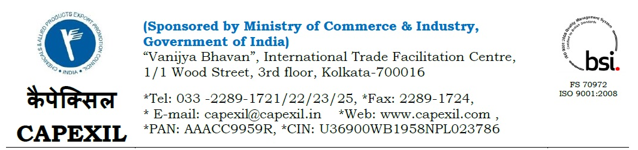
CAPEXIL/ED/INDIA SHOW/MAI/17-18/ 16-05-2017

Seeking Proposal for
Organizing India Show by CAPEXIL for Building & Construction Materials and Rubber Products falling under the purview of CAPEXIL under the Trade Promotion Program of MOC&I, GOI during 2018-19

Greetings from CAPEXIL – India’s Premier International Trade Facilitation& ExportPromotion Council under the Ministry of Commerce & Industry, Govt. of India.

We are pleased to inform your good selves that as a part of export promotional programme, CAPEXIL decided to organize an India Show with 300 (approx) Indian & foreign Exhibitors and inviting 150 (approx) foreign delegates exclusively for the sector of Building & Construction and Rubber Products under MAKE IN INDIA Initiative of the Govt. of India.The detailed proposal with justification, budget, DPR etc. to be submitted very shortly to the MOC&I, Govt. of India for approval.

Considering the above, we are looking for a professional stall designer, fabrication work with complete exhibition solution / event management company to have their services for organising the stated event. Our tentative requirements are as follows:-
- Profile of your company.

- Credentials of your company.

- Detailed of Similar event done with complete information of the clients.

- Detailed presentation on the above covering

- Detailed Planning & Organizing including budgeting, scheduling, site selection, acquiring necessary permits, coordinating transportation and parking, arranging for speakers or entertainers, arranging decor, event security, catering, coordinating with third party vendors, and emergency plans
- Documentation
- Teamwork
- Communication and Negotiation
- Areas of responsibility
- Maintenance
- Legacy
- In addition to above as you deem fit.

In view of the above If you are interested to be a part of the above initiative of CAPEXIL, please response by return mail latest by 30th May 2017 to:

The Executive Director,
CAPEXIL
ed@capexil.in
under copy to secretariat@capexil.in, priyanka.tarafdar@capexil.in&accounts@capexil.in.

