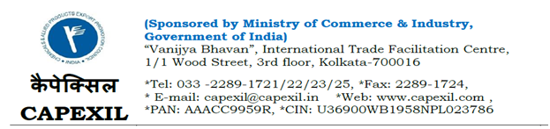

Interactive Session and Training Programme on E-Way Bill
Ref: EPC:HO:PT:E-Way Bill:2018:1550
26th Feb 2018
Dear Member,

We are pleased to inform you that, CAPEXIL in association with EPCES is organizing an Interactive Session and Training Programme on E-Way Bill as per the below-mentioned schedule:

Date | Tuesday, February 27, 2018
Time | 03.00 pm to 5.00 pm
Venue | Conference room, Manikanchan SEZ, Office of the Development Commissioner,  3 Floor, CF - Building, Plot no-1, Sector- V, Salt Lake, Kolkata- 700 091
Speakers | Chief Guest- Shri Devendra Nagvenkar, Hon’ble Commissioner, CGST Kolkata North Commissionerate  Guest Speaker- Shri Ankan Bose, Superintendent, CGST, Shri Partha Santra, Superintendent, CGST

As you know, the E-way bill, short form for electronic way bill, is a document to be generated online under the GST system, when goods of the value of more than Rs. 50,000/- are shipped inter-State or intra-State.

The E-way bill must be raised before the goods are shipped and should include details of the goods, their consignor, recipient and transporter. The transporter has to carry the invoice and the copy of E-way bill as support documents for the movement of goods. He can also carry the E-way bill number, mapped to an RFID (radio frequency identification device).

To be ready with this process, CAPEXIL and EPCES are organizing an exclusive Interactive Session and Training Programme on E Way Bill with Senior Officials from Central Excise Kolkata. This session will cover the following:

- GST E Way bill Registration
- Supply in E Way Bill &E Way bill validity period
- Situations where E- Way Bill is not required to be generated
- Verification of documents & Conveyances & inspection of goods

Interested members are requested to kindly send their confirmation to Ms. Nabanita Nandi at media@capexil.in or Ms. Priyanka Tarafdar at priyanka.tarafdar@capexil.in as early as possible.

Warm regards,

T.K.Bhattacharyya
Executive Director
CAPEXIL

