Interactive Session and Training Programme on E Way Bill
CAPEXIL in association with EPCES organized an Interactive Session and Training Programme on
E Way Bill on 27th February at the Manikanchan, SEZ, Salt Lake, Kolkata.

The E-way bill or the electronic way bill, is a document to be generated online under the GST system, when goods of the value of more than Rs. 50,000/- are shipped inter-State or intra-State. The E-way bill must be raised before the goods are shipped and should include details of the goods, their consignor, recipient and transporter. The transporter has to carry the invoice and the copy of E-way bill as support documents for the movement of goods. The person can also carry the E-way bill number, mapped to an RFID (radio frequency identification device).

The primary aim of the event was to make the attendees aware of the rules, regulation and significance of the E Way Bill. This session also threw light on the following:

- GST E Way bill Registration process
- Supply in E Way Bill &E Way bill validity period
- Situations where E- Way Bill is not required to be generated
- Verification of documents & Conveyances & inspection of goods

The Session was graced by Shri Devendra Nagvenkar, Hon’ble Commissioner, CGST Kolkata North Commissionerate as the Chief Guest. Shri J. M. Gupta, Development Commissioner, Kolkata SEZ, Ministry of Commerce and Industry, Department of Commerce, GoI also addressed the Session.
Illustrative PPT on E-Way Bill was presented by Shri Partha Santra, Superintendent,CGST and Shri Ankan Bose, superintendent, CGST.
Shri C. R. Bhattacharjee, Chairman- Eastern Region, CAPEXIL also graced the occasion as a distinguished panellist.

Event Photographs

Shri Partha Santra, Superintendent,CGST presenting a PPT to explain the rules associated to the E-Way Bill
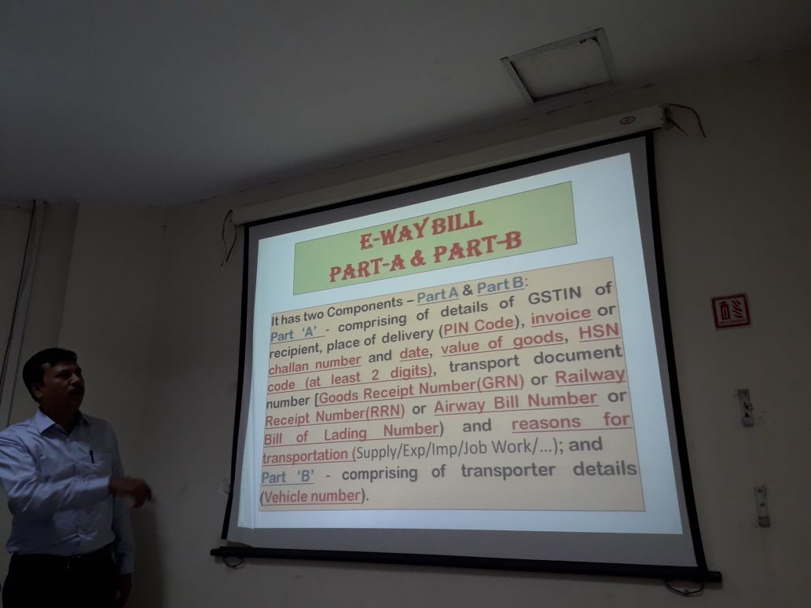

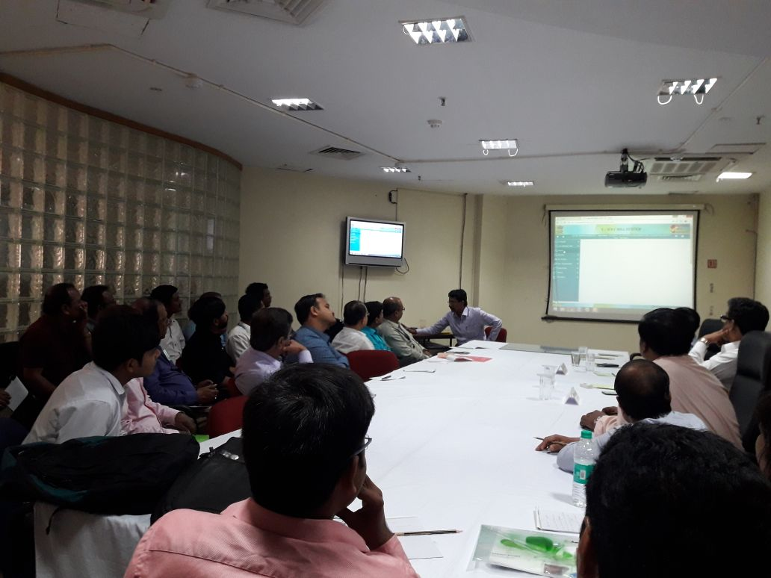

Shri Ankan Bose, superintendent, CGST explaining the online E-Way registration process
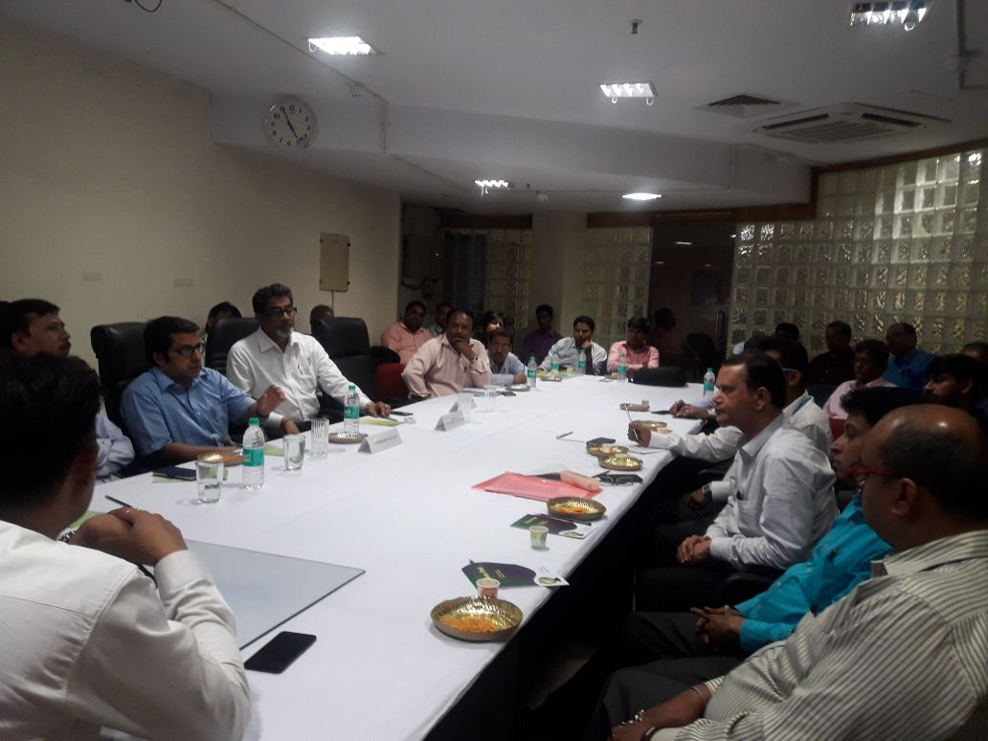

Shri Devendra Nagvenkar, Hon’ble Commissioner, CGST Kolkata North Commissionerate and Shri C. R. Bhattacharjee, Chairman- Eastern Region, CAPEXIL addressing the Session

