Overview of the Half Day Training Programme on
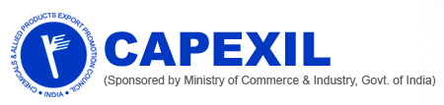
“Product Market Identification and Market Entry Strategy”
24th April 2018, Kolkata
CAPEXIL in association with Export Promotion Council for EOUs & SEZs organized a Training Programme on “ Product Market Identification and Market Entry Strategy” on 24th April 2018 at EEPC Conference Hall Kolkata.
The programme was designed keeping in view the free trade regime and economic reforms as initiated by Govt. of India as well as the impetus given to international trade, accelerate growth rate of export under the ‘Make in India’ regime. The programme primarily focused on making exporters aware of the strategies associated to identify a new market and how to enter the market by using advanced tools.
To illustrate the issue we had Dr. Gautam Dutta, Professor IIFT as the key note speaker. Dr. Dutta is an expert in Marketing Management, Technology Innovation Management, Entrepreneurship, Small Business Development and in Internal Marketing. The event was also graced by Mr. S.K. Ghosh, Past National Chairman and Chairman of Ceramics and Allied Products including Refractories Panel, CAPEXIL, Mr. C.R. Bhattacharjee, Regional Chairman, CAPEXIL, Mr. T.K. Bhattachryya, ED, CAPEXIL and Dr. Sabyasachi Ghosh, Regional Director, Export Promotion Council for EOUs & SEZs.
The programme was attended by approximately 30 exporters. The attendees gave a very positive feedback about the session. A simplified way of explaining the important issue of Product market identification and market entry strategies turned out to be really helpful to all of the delegates.
Key takeaways:
Dr. Dutta explained 7 easy steps to identify right market and the strategies to be followed to enter the same
Step1:
Find out the RCA (Revealed Comparative Advantage) Value which shows the strength of the product. By following the website www.tradegroup.com the RCA value can easily be identified. The revealed comparative advantage is an index used in international economics for calculating the relative advantage or disadvantage of a certain country in a certain class of goods or services as evidenced by trade flows.

Step 2:
Ways to select the correct market for the product. The country which has a relative growth rate in terms of the import of the product should be considered the right market.

Step 3:
Short listing the country by using Shift Share method

Step 4:
To understand the competition existing in the shortlisted market and to have an idea about the completion one can visit www.tradegroup.org and chose the target country. This will show the share of all the countries who are exporting the product to the target market.

Step 5:
Identify the ease of exporting the product to the targeted market by following the below mentioned levels.
- www.doingbusiness.org

- Ranking

- Required Details pertaining to the chosen country

Step 6:
Understand the import barriers in terms of Import Duties. That means to find out if there is any Bilateral Trade agreement existing between the two countries for the product. APTIAD is the website one can visit to know about the treaties existing between two countries.
There are six different types of Bilateral Agreements:
- Preferential Trade Agreement: A trade pact between countries that reduces tariffs for certain products to the countries who sign the agreement.
- Free Trade Agreement: A Treaty between two or more countries to establish a free trade area where commerce in goods and services can be conducted across their common borders, without tariffs or hindrances but capital or labor may not move freely.
- Comprehensive Economic Partnership Agreement: By signing this trade agreement the countries will enjoy a number free tariff lines as well as the qualification of people from a country will be regarded the same way in the other country.
- Customs Union: A group of states that have agreed to charge the same import duties as each other and usually to allow free trade between themselves.
- Customs Market: it is the combination of Comprehensive Economic Partnership Agreement Customs Union
- Economic Union: A group of countries under this agreement will get the benefits of the above three trade agreements plus they will have the same currency

Step 7:
Find out the tariff duty in the destination or target market by following the below mentioned levels
- Visit Trade Map Website

- Other ITC Tool

- Market Access Map

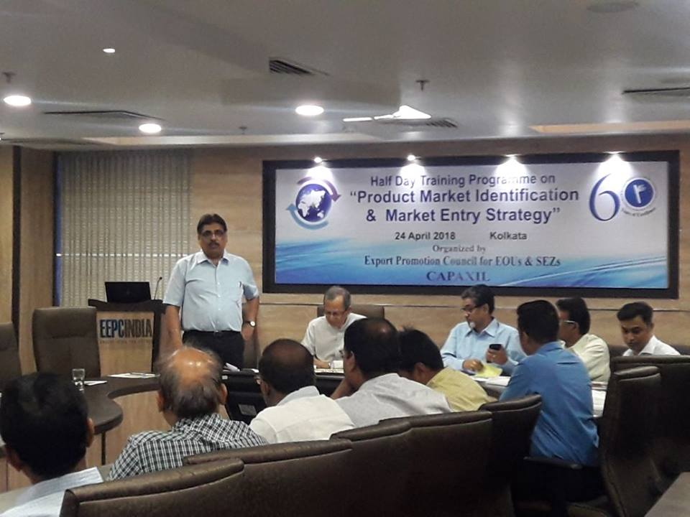

Dr. Gautam Dutta, Professor, IIFT adressing the Training Programme on "Product Market Identification and Market Entry Strategy", 24th April 2018, Kolkata, organised by CAPEXIL and Export Promotion Council for EOUs and SEZs

