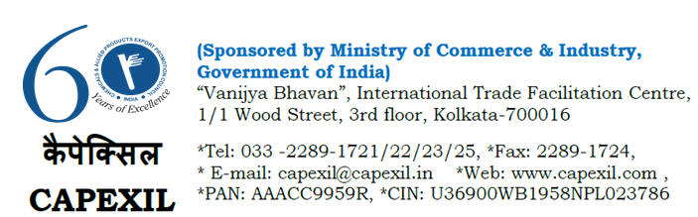

To the Members of 1> Books, Publications and Printing Panel
2>Paper, Paper Board and Paper Products Panel

Dear Sir(s),
We are pleased to inform you that the Embassy of India, Santiago has conveyed us that a Chilean buyer will be travelling to India shortly.
We have learnt from the communication that the company is looking forward to meet few leading suppliers of stationery and school items from India.
In this regard we would like request all the interested members of this panel to contact the Embassy of India, Santiago at com1.santiago@mea.gov.in for any further details or assistance.
Please note that the Council is not aware about Financial Standing and Business Commitment of the said foreign company. CAPEXIL is not responsible for any financial or trade dispute or any business matter whatsoever in nature and has no obligation to any member / concerned stakeholder. Interested Members are required to check the credit worthiness of the said firm through their own source and may enter into any transaction on their own risk and consequences.

Please appreciate that the Council is just a facilitator to their member exporters for promotion of their International Trade by circulating such trade enquires in the best interest of the concerned Industry.

Warm Regards,

T.K.Bhattacharyya
Executive Director
60 years of Export Promotion (1958-2018)
www.capexil.org

