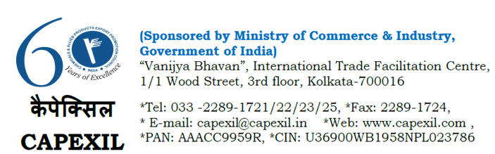
To All the Members of the Paper, Paperboard and Paper Products Panel of CAPEXIL

Date: 8th May 2018

Dear Members,

Greetings from CAPEXIL – India’s Premier International Trade Facilitation & Export Promotion Council under the Ministry of Commerce & Industry, Govt. of India.

An Ethiopian company named Subi Printing Press has communicated us with their interest of importing 45gm bank paper in different colours, 80gm wood free paper, Art paper 100,150,250grm from India.

They have requested to contact them with best quotations. May we request all the interested members to kindly contact them on +251911085528 or email at lifeab_22@yahoo.com with a copy to secretariat@capexil.in

Please note that the Council is not aware about Financial Standing and Business Commitment of the said foreign company. CAPEXIL is not responsible for any financial or trade dispute or any business matter whatsoever in nature and has no obligation to any member / concerned stake holder. Interested Members are required to check the credit worthiness of the said firm through their own source and may enter into any transaction on their own risk and consequences.

Pls. appreciate that the Council is just a facilitator to their member exporters for promotion of their International Trade by circulating such trade enquires in the best interest of the concerned Industry.

Warm Regards,

T.K.Bhattacharyya
Executive Director
60 years of Export Promotion (1958-2018)
www.capexil.org

