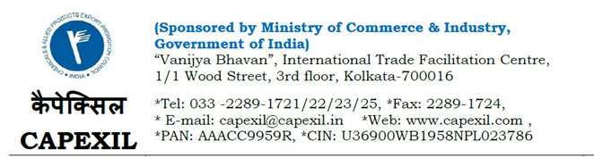
Ref. No.: CAPEXIL/VRC/Export Award/2023-24 / 59 Dated 23rd August, 2023

To All Constituents of Capexil

Dear Sir,

Sub: Export Excellence Awards Presentation Ceremony by CAPEXIL
for the F.Y. 2017-18 to F.Y. 2021-22

Greetings from CAPEXIL…..

The Council is glad to inform your good selves that Capexil Export Award Presentation Ceremony will be held on 16thSeptember,2023 at Vigyan Bhawan, New Delhi. Shri OM Birlaji, the Hon’ble Speaker of Lok Sabha has kindly consented to grace the occasion as the Chief Guest.

Details of the program are given below:

* | Day & Date: | Saturday, the 16th September, 2023
* | Registration Time: | 9.00 AM to 9.45 AM
* | Tea/ Coffee: | 9.45 AM to 10.25 AM
* | Venue: | Plenary Hall, Vigyan Bhawan, Maulana Azad Road, New Delhi- 110011

We cordially request you to attend the above function.

A line of confirmation in this regards to: exportaward@capexil.in is indeed appreciated by return email.

With kind regards,

V.R.Chitalia
Director, CAPEXIL

