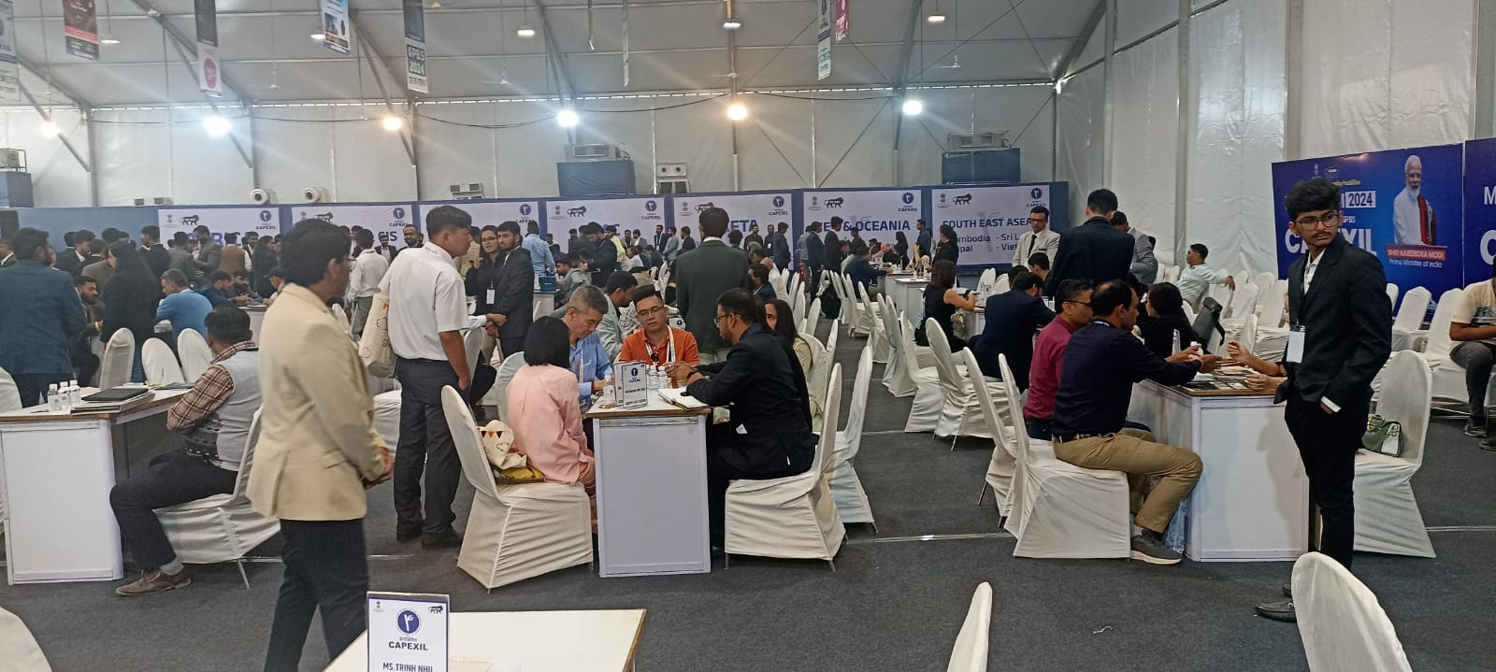
CAPEXIL’s Mega Reverse Buyer Seller Meet for Ceramic and Sanitary ware products
in progress at Rajkot, Gujarat

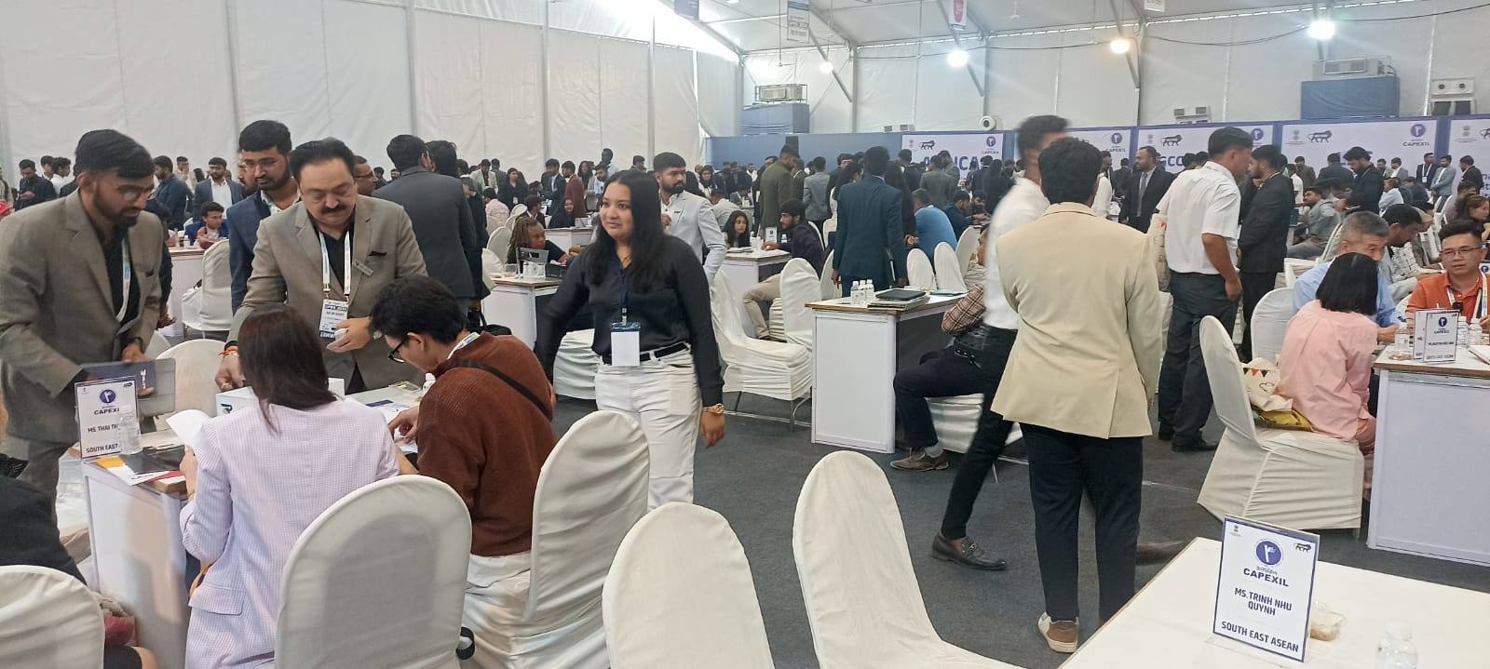
CAPEXIL’s Mega Reverse Buyer Seller Meet for Ceramic and Sanitary ware products
in progress at Rajkot, Gujarat

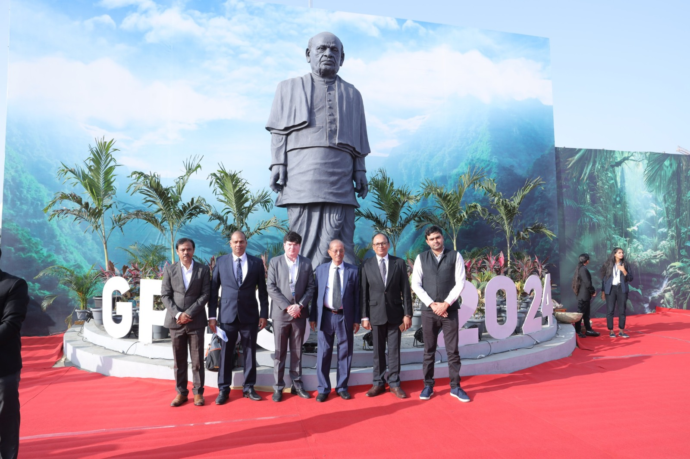
Mr Ramesh K Mittal, President, CAPEXIL (third from right) along with Mr. Senjeet Kumar, Deputy Director General, EP CAP Department, MoC (second from right) and Mr. Nilesh Jetpariya, Senior Vice Chairman, Ceramic and Allied Products, CAPEXIL (3rd from left) at event ground

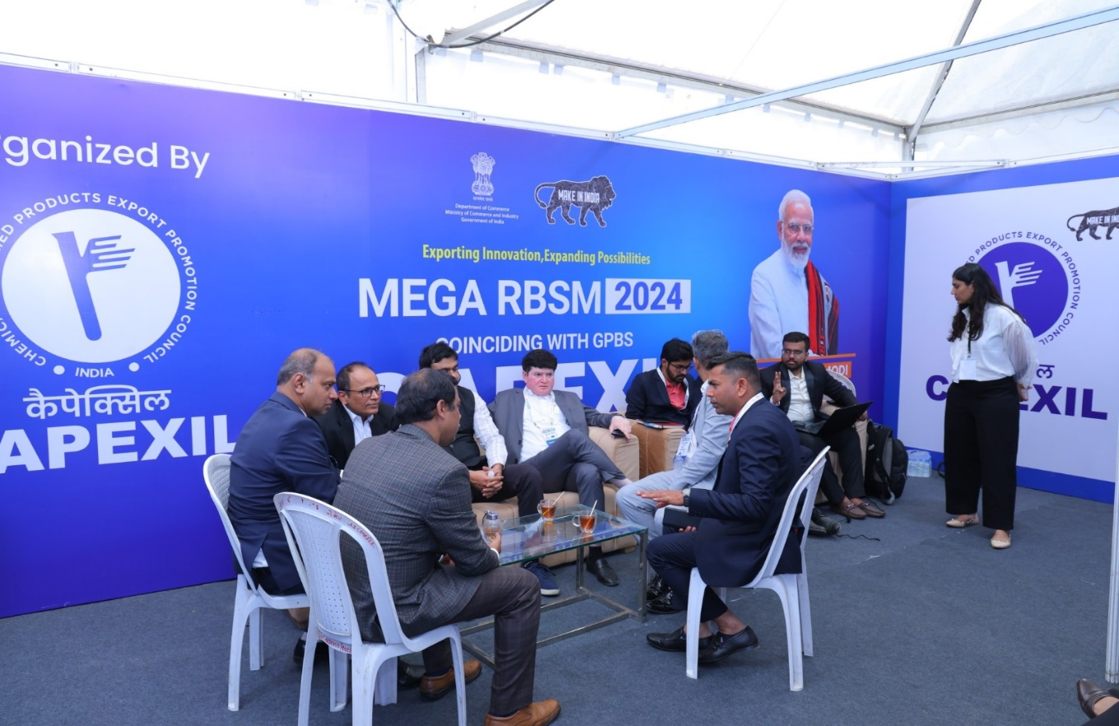Mr. Senjeet Kumar, Deputy Director General, EP CAP Department, MoC and Mr. Nilesh Jetpariya, Senior Vice Chairman, Ceramic and Allied Products, CAPEXIL meeting with organising team

